Continuous Assessment Examination 2

Program : B.E-CSE/B.TECH-IT Max. Marks: 30
Course : Machine Learning Time: 1.15 Mins.
Course Code: SCSA1601 Sem : VI
Batch : 2019-2023 Date: 5.4.2022
Part-A Answer ALL the questions (5×2=10)

Q.No | Questions | CO
 | Compare and contrast Single linkage, complete linkage clustering methods | 3
 | Given two objects represented by (10,5,32,28) and (12,0,16,4):  a)Compute Euclidean distance between the two objects | 3
 | Highlight the formula for Information gain (Entropy)? | 3
 | Justify the significance of Multi Layer Perceptron. | 4
 | Sketch a neural network that solves OR gate. | 4

Part-B Answer ALL the questions (2×10=20)

Q.No | Questions | CO
 | Compose the decision tree using Decision Tree Induction. | 3
  Owns Home | Married | Gender | Employed | Class
  Yes | Yes | Male | Yes | B
  No | No | Female | Yes | A
  Yes | Yes | Female | Yes | C
  Yes | No | Male | No | B
  No | Yes | Female | Yes | C
  No | No | Female | Yes | A
  No | No | Male | No | B
  Yes | No | Female | Yes | A
  No | Yes | Female | Yes | C
  Yes | Yes | Female | Yes | C
 | (OR)
 | Evaluate the clusters using the Single linkage Hierarchical Clustering for the distance matrix and draw its Dendogram. | 3
   | A |  | B | C | D | E | F
  A | 0
  B | 0.71 |  | 0
  C | 5.66 |  | 4.95 | 0
  D | 3.61 |  | 2.92 | 2.24 | 0
  E | 4.24 |  | 3.54 | 1.41 | 1.00 | 0
  F | 3.20 |  | 2.50 | 2.50 | 0.50 | 1.12 | 0

 | Construct a Single Layer perceptron and explain it with an example. | 4
 | (OR)
 | Solve using Back propagation neural network algorithm. Given:  Learning rate = 0.9, Class label (Target T_{j}) = 1.  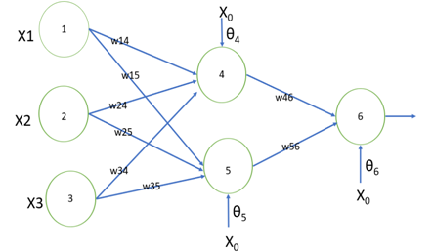 | 4
  X1 | X2 | X3 |  | W14 | W15 |  | W24 |  | W25 | W34 |  | W35 | W46
  1 | 0 | 1 |  | 0.2 | - 0.3 |  | 0.4 |  | 0.1 | - 0.5 |  | 0.2 | - 0.3
  W56 |  |  | Ɵ4 |  |  | Ɵ5 |  | Ɵ6
  - 0.2 |  |  | - 0.4 |  |  | 0.2 |  | 0.1

